These pages are designed to show you how to use software packages; various software updates may have taken place so some pages will not apply to versions other than those listed here. In some cases data files may be required.

Title or Task: | Excel is Introduction
Description: | Using Excel

Files Required
Suitable for Classes: | AIT • Multimedia • Cert II IT • Cert II Bus
Area: | Technology & Enterprise
Teacher: | Mr Peter Faulks

Timeline

Date Due:
Task Brief: | In class lesson
Outcomes: | Begin using Excel

Items highlighted in yellow are tasks for you to complete

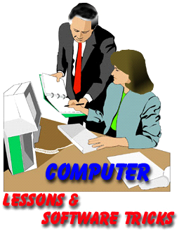
Items in Blue italics are help tips

